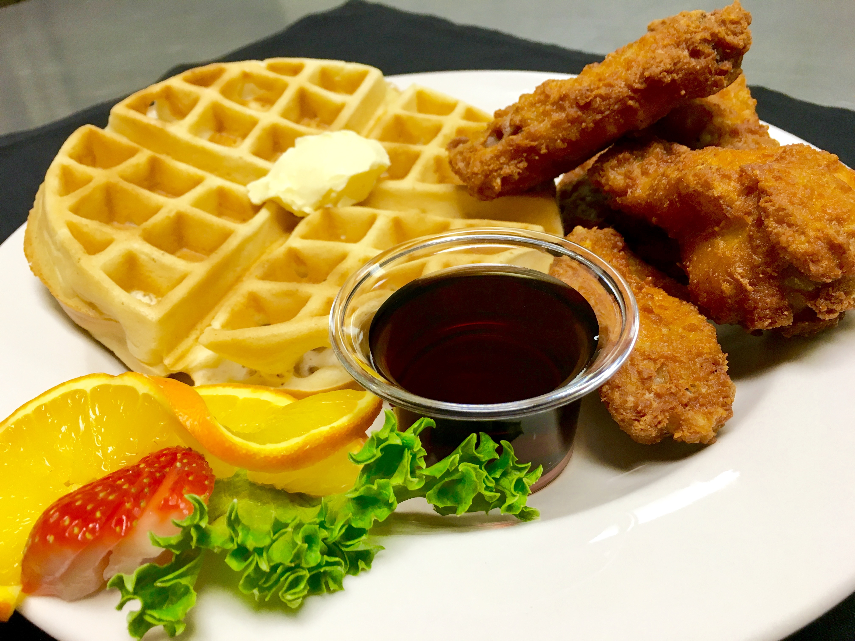
Catering Rental Agreement
Charlie’s Catering is a full service catering company, with a friendly and professional staff. We use select, hand-picked fresh ingredients and prepare all food the morning of the event so everything is as fresh and tasty as it can possibly be!  Contact us and let us know about your next event. We’ll help you plan the perfect catering set up for your specific needs and budget. Charlie’s has you covered.  Whether it’s a company outing, sales team event, or anything else your company needs to provide catering and quality food for, we can handle events for companies of any size.  Sometimes it’s a corporate function, other times it’s a wedding reception, or youth events. Whatever the case, our friendly and discreet staff will be there to help.  Banquet Rooms Available  Please contact us to inquire about our banquet room choices seating 100-5000 guest.  Give your guest the best! |  | Wedding Reception Set Up  Fresh Fruit Fountain

Meals & Service
Starting at $9.95 per person
This includes a variety of custom menu options guaranteed to satisfy your guest.

Give Your Guest the Best!
A guaranteed guest count is required 72 hours prior to the event, in writing to the Event Manager.
Guest counts cannot decrease after this time. Guest counts can only increase with approval
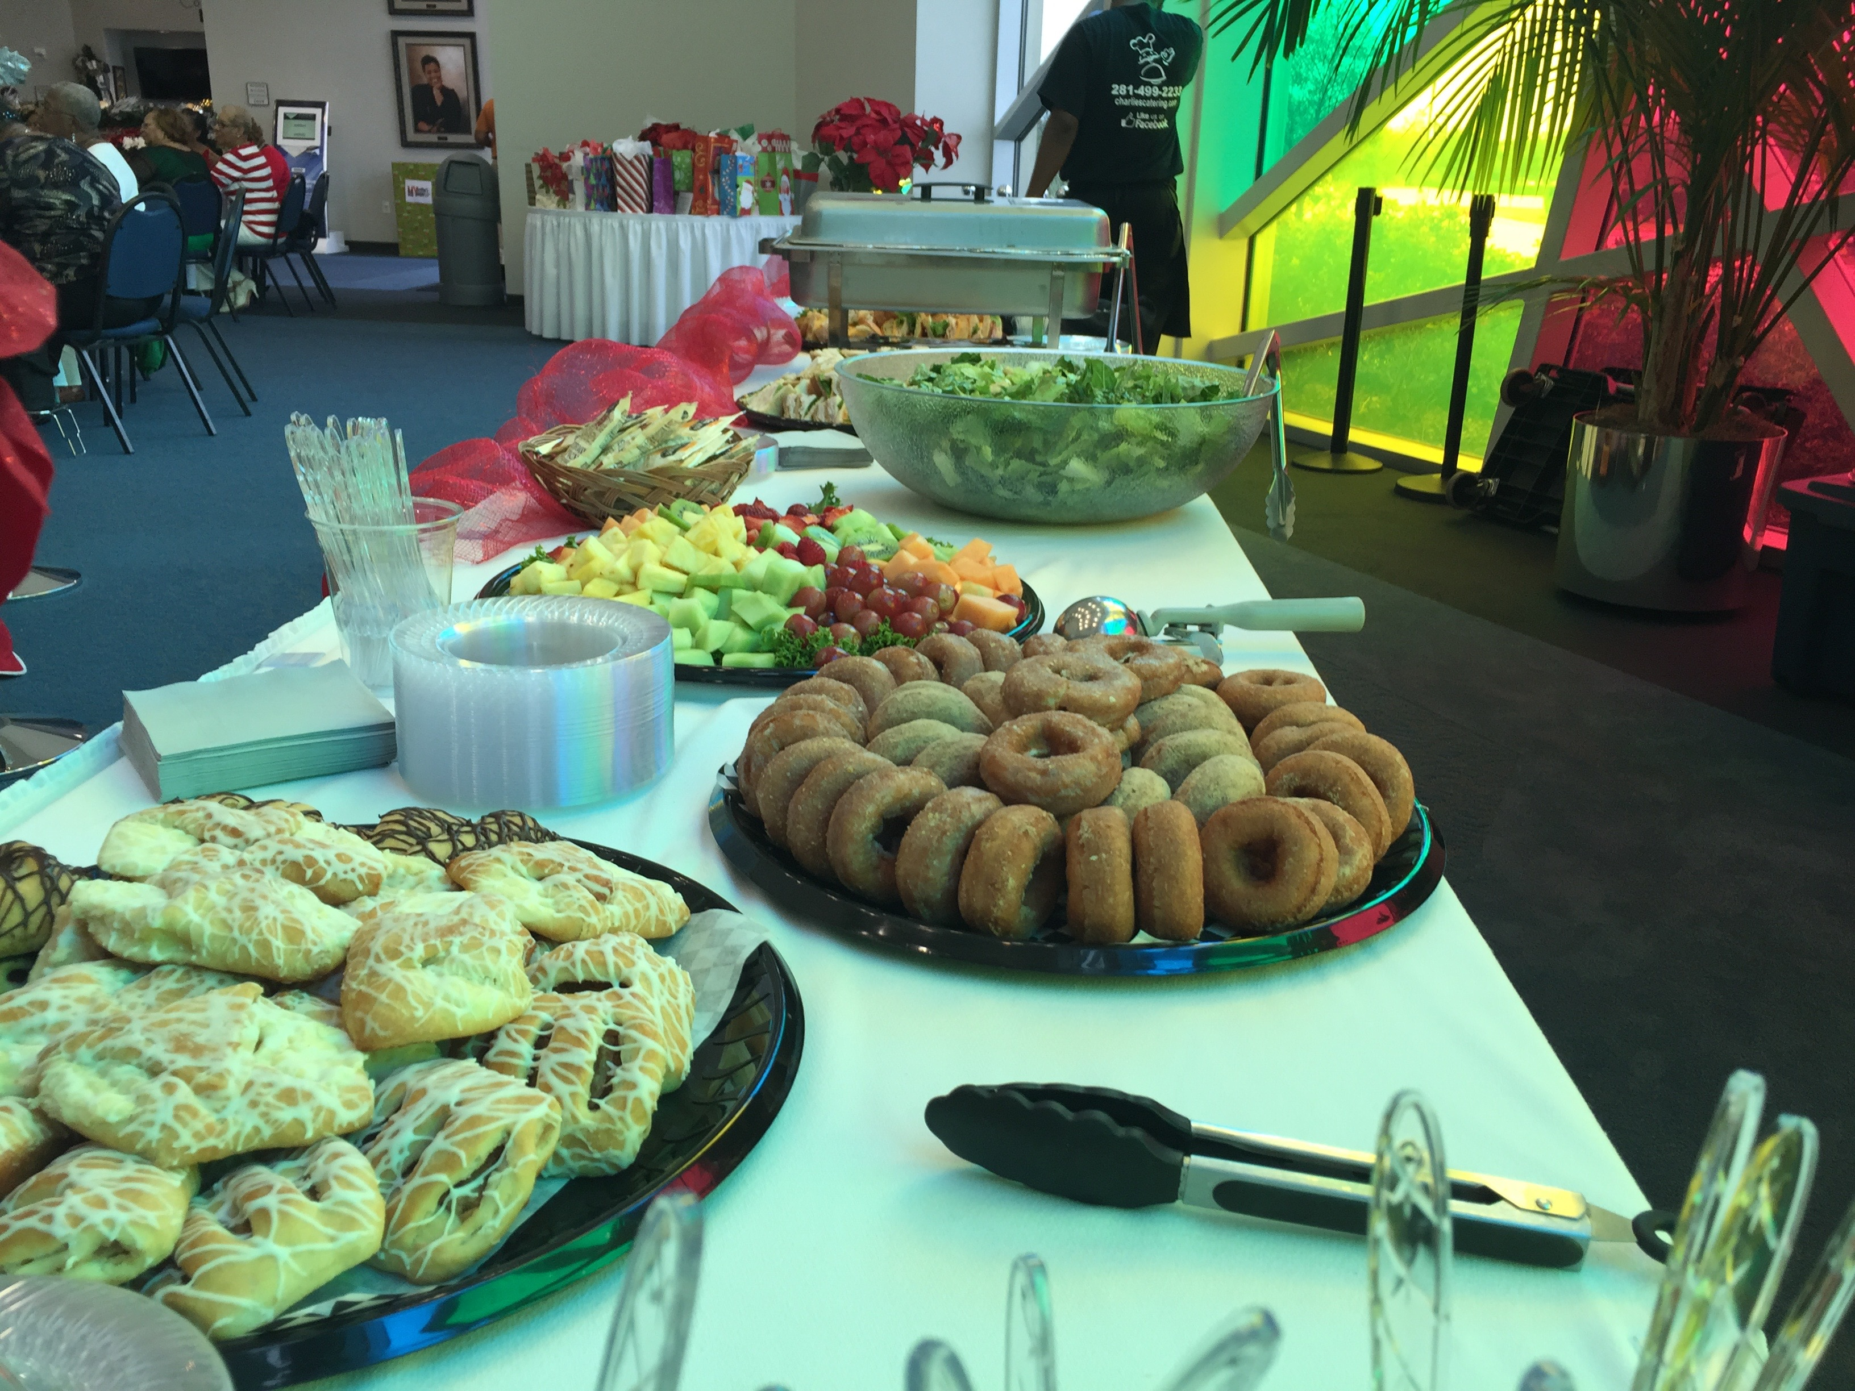 |  | Actual Charges:  The larger of: (i) the Food & Beverage Minimum, or (ii) the actual cost of all food and beverage charged in accordance with the final signed contract + 8.25% sales tax + 21% Service charge.

Deposit
A deposit in the amount of 20% will be implemented at the time of booking your event.

Cancellations
We understand that cancellations sometimes occur. If your cancellation is 120 days before the event, 100% of your payment will be returned. If it occurs 30 days before 50% of your payment will be returned.

Client Name: Phone:

Company: Email:

Event Date: Event Time:

Amount of Deposit: Number of Guest:

Balance Due: Due Date:

Selected Menu:

Client Signature: Accepted by: (Charlie’s Representative)

Date: Date:

